

***TUGAS COMPUTER NETWORK***

Nama Kelompok :

-Indra Gunawan - 2101660121

-Muh Rifky Idris - 2101684235

-Nicholas - 2101645114

-Vincent Thamrin - 2101693426

TOPOLOGY

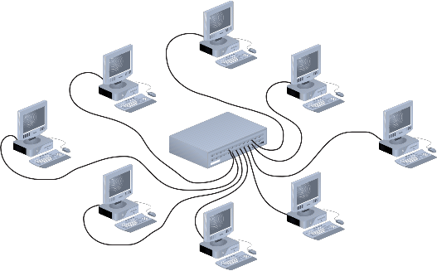 Topology yang kelompok kami gunakan adalah Topology Star. Kami memilih Topology Star karena bersifat fleksibel, Keamanan data yang tinggi, Mudah dalam mendeteksi kerusakan pada jaringan dan jika salah satu komputer mengalami kerusakan, Jaringan akan tetap berjalan dan tidak menimbulkan masalah bagi komputer lain.

Lantai 1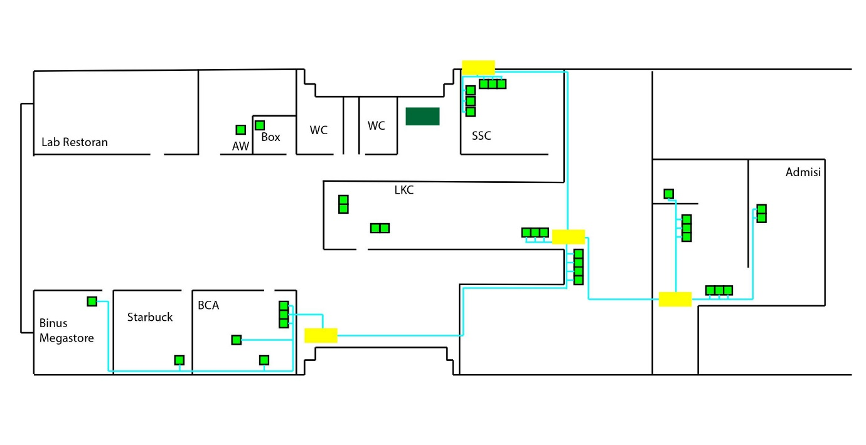

Komputer = 32

Switch = 4

Router = 1

NA: 192.168.100.0

BA: 192.168.100.80

IP-range: 192.168.100.1-192.168.100.79

Subnet mask: (Binary) = 11110000 00000000 00000000 00000000

(Decimal) = 240.0.0.0

Lantai 2

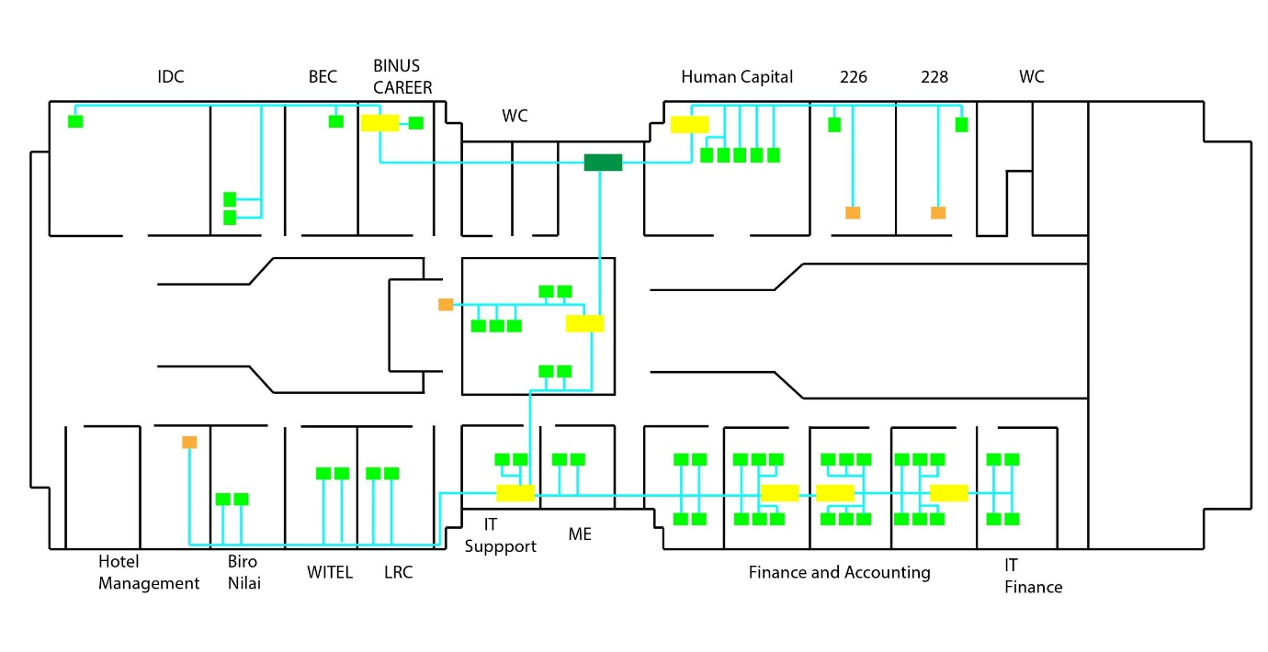

Komputer = 56

Switch = 6

Router = 1

Mesin Tap = 4

NA: 192.168.100.81

BA: 192.168.100.160

IP-range: 192.168.100.82-192.168.100.159

Subnet mask: (Binary) = 11111000 00000000 00000000 00000000

(Decimal) = 248.0.0.0

Lantai 3

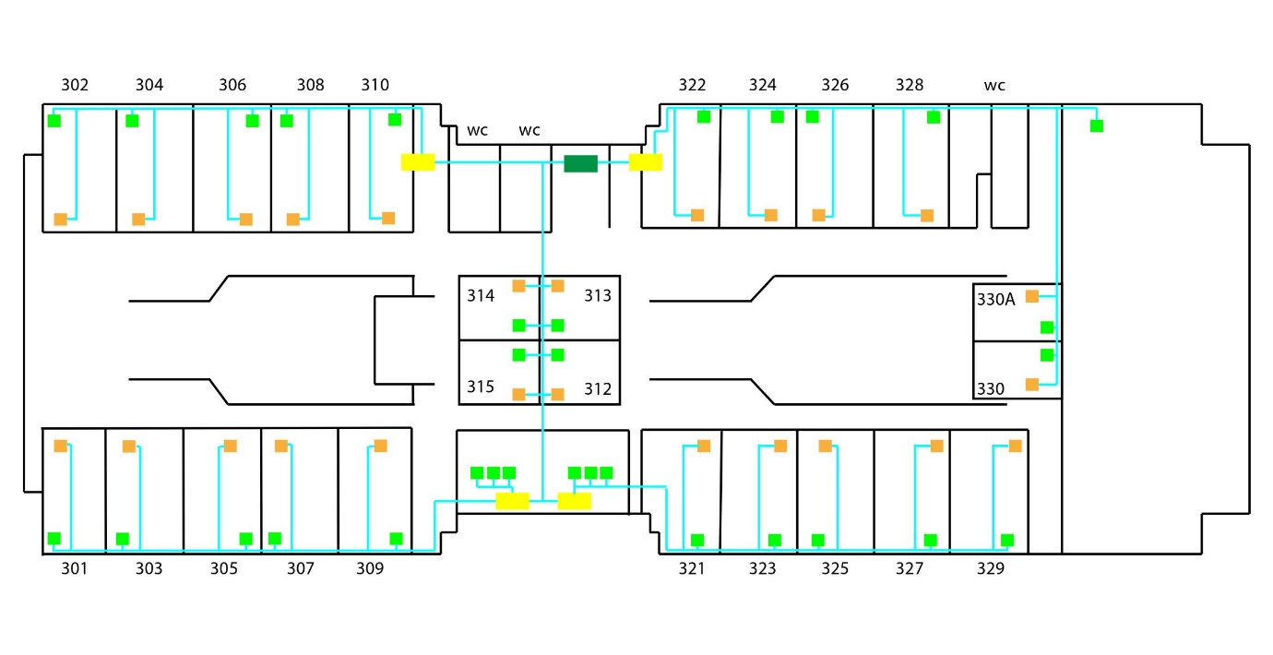

Komputer = 32

Switch = 4

Router = 1

Mesin Tap = 25

NA: 192.168.100.161

BA: 192.168.100.255

IP-range: 192.168.100.162-192.168.100.254

Subnet mask: (Binary) = 11111100 00000000 00000000 00000000

(Decimal) = 252.0.0.0

Lantai 4

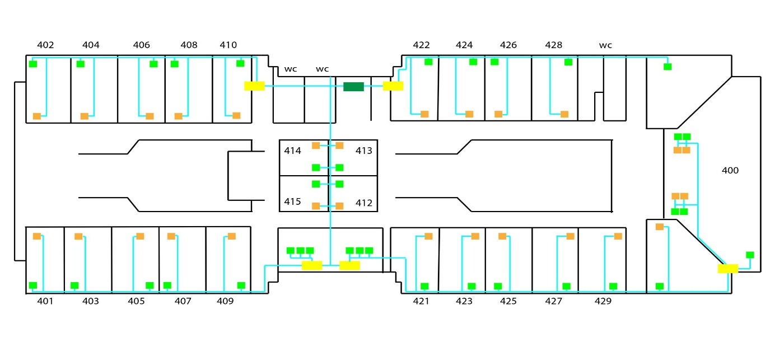

Komputer = 33

Switch = 6

Router = 1

Mesin Tap = 32

NA: 192.168.100.256

BA: 192.168.100.315

IP-range: 192.168.100.257-192.168.100.314

Subnet mask: (Binary) = 11111110 00000000 00000000 00000000

(Decimal) = 254.0.0.0

Lantai 5

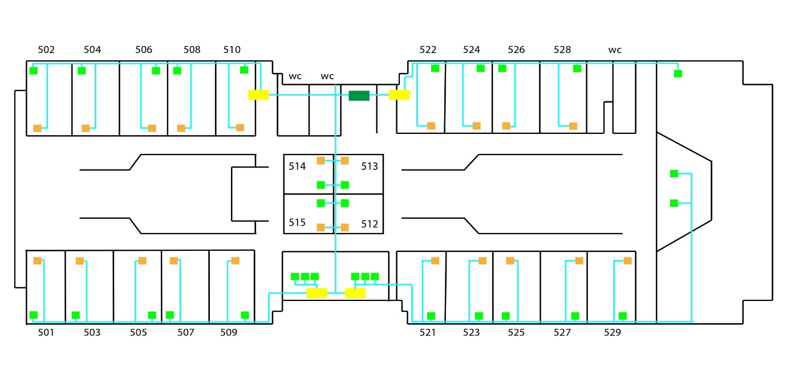

Komputer = 31

Switch = 5

Router = 1

Mesin Tap = 25

NA: 192.168.10.0

BA: 192.168.10.90

IP-range: 192.168.10.1-192.168.10.89

Subnet mask: (Binary) = 10110100 00000000 00000000 00000000

(Decimal) = 184.0.0.0

Lantai 6

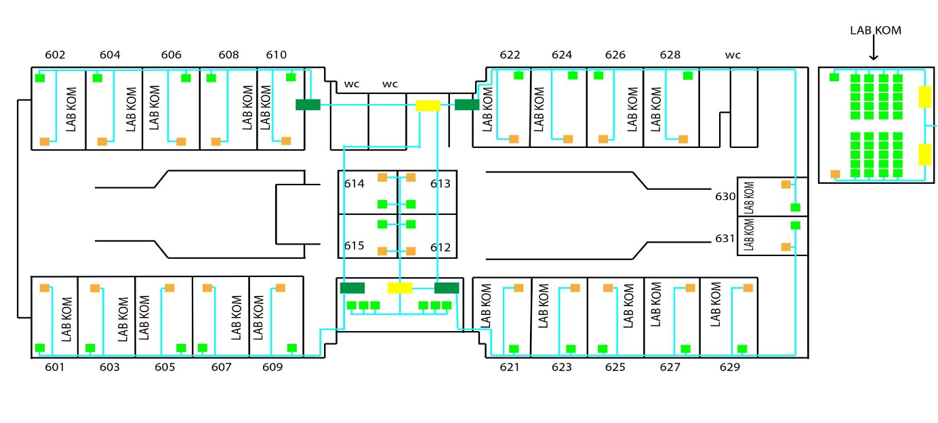

Komputer = 871

Switch = 4

Router = 4

Mesin Tap = 25

NA: 192.168.10.91

BA: 192.168.10.155

IP-range: 192.168.10.92-192.168.10.155

Subnet mask: (Binary) = 10110101 00000000 00000000 00000000

(Decimal) = 185.0.0.0

Lantai 7

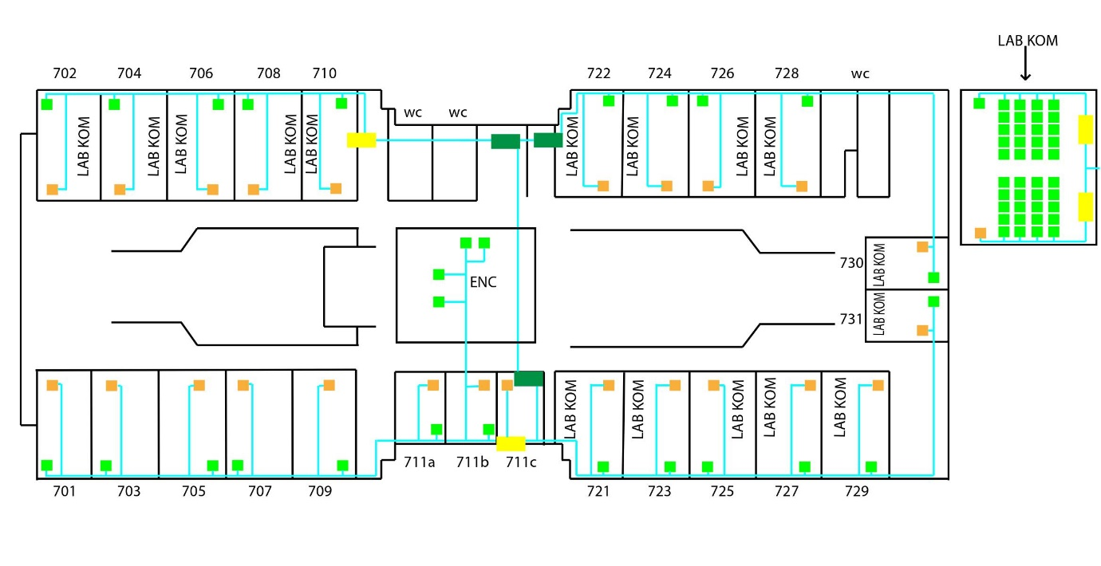

Komputer = 588

Switch = 4

Router = 3

Mesin Tap = 24

NA: 192.168.10.156

BA: 192.168.10.200

IP-range: 192.168.10.157-192.168.10.199

Subnet mask: (Binary) = 11110101 00000000 00000000 00000000

(Decimal) = 249.0.0.0

Lantai 8

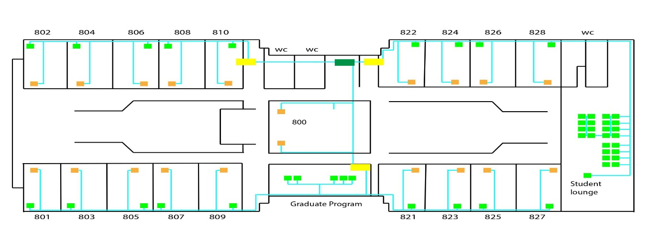

Komputer = 54

Switch = 3

Router = 1

Mesin Tap = 14

NA: 192.168.10.201

BA: 192.168.10.256

IP-range: 192.168.10.202-192.168.10.255

Subnet mask: (Binary) = 11110111 00000000 00000000 00000000

(Decimal) = 247.0.0.0